LEAP Road Transport Model Guide
Using the prepared road model inputs inside LEAP
Revised modeller-facing draft
Purpose
This guide explains how to use the APERC road transport model once the road input package has been prepared for LEAP. It focuses on practical modelling: what to import, what to check, what can be changed in LEAP, and what should be changed through the pre-LEAP road workflow instead.

Minimum mental model
Road transport energy is driven by vehicle stock, annual mileage, fuel economy or efficiency, technology shares, and fuel shares. The pre-LEAP interface and Python workflow prepare the stock-flow structure and reconcile the base year to ESTO. LEAP then runs the official projection inside the wider APERC energy system model.

Note that this is meant for after the pre-LEAP workflow has been completed for the economy being modelled in LEAP. Do this at https://huggingface.co/spaces/finbarmaunsell/leap_road_model

Contents
- 1. Who this guide is for
- 2. The road model in one page
- 3. Overall workflow: interface, Python, LEAP, dashboards
- 4. What is prepared before LEAP
- 5. Downloading and importing road inputs
- 6. Setting lifecycle profiles in LEAP
- 7. Road branch structure in LEAP
- 8. Variables by branch level
- 9. What users can change in LEAP
- 10. Walkthroughs for common modelling changes
- 11. What users should not change directly in LEAP
- 12. Checking the model after changes
- 13. Common problems and how to diagnose them
- 14. Glossary
- Appendix A. Current road branch scope
- Appendix B. Screenshot reference from the original guide

1. Who this guide is for
This guide is for modellers who need to use, review, or adjust the LEAP road transport model after the road model interface and Python workflow have produced LEAP-ready inputs.
It is not a full developer guide. It does not explain every Python module, table, or configuration file. It also does not replace the road methodology guide. The aim is to help a modeller understand where the road inputs come from, where they appear in LEAP, which variables can be adjusted safely, and which changes should be made outside LEAP instead.
Practical rule
Use the interface and Python workflow for base-year evidence, reconciliation, stock-flow setup, and structural assumptions. Use LEAP for the official projection run and for controlled scenario changes such as technology sales shares, mileage adjustments, and efficiency adjustments.

2. The road model in one page
The road model estimates road transport energy demand by fuel. It covers passenger road and freight road, including LPVs, motorcycles, buses, trucks, and light commercial vehicles.
The basic calculation is:
Energy = vehicle stock × mileage × energy use per kilometre
In parts of the current Python workflow, efficiency is represented as distance per unit energy, such as km/GJ. In that case the relationship is:
Energy = stock × mileage / fuel economy
Unit warning
Always check the units shown in LEAP before interpreting a fuel economy change. If the value is energy per kilometre, a higher value increases energy use. If the value is distance per unit energy, such as km/GJ, a higher value reduces energy use.

The road model is a stock-flow model. Sales add new vehicles to the fleet. Survival and vintage profiles determine how many vehicles retire. Sales shares determine which technologies enter the fleet. Mileage and fuel economy then determine how much energy those vehicles use.
Model part | Plain-English meaning | Main effect
Stock | How many vehicles are on the road. | More stock usually increases energy use.
Sales | New vehicles entering the fleet each year. | Controls how quickly the fleet can change.
Retirements | Vehicles leaving the fleet. | Creates room for replacement sales and new technologies.
Sales Share | How new sales are split across vehicle types and technologies. | Changes future technology stock gradually through turnover.
Mileage | Average distance travelled per vehicle per year. | Changes energy use directly, without changing stock.
Fuel Economy / Efficiency | Energy needed for travel, or distance travelled per unit of energy depending on units. | Changes energy use directly.
Device Share | Fuel split within a technology branch. | Determines how a branch is allocated across fuels.

3. Overall workflow: interface, Python, LEAP, dashboards
The workflow has four parts. Users may not interact with every part, but understanding the split helps avoid changing the wrong variable in the wrong place.
Stage | What it does | What the user should do
Interface | Provides a focused place to review road inputs, update assumptions, add notes, and download outputs. | Review the assumptions before export. Use this for base-year evidence and structural assumptions.
Python workflow | Builds branch-level inputs, projects stock targets, prepares sales and turnover, reconciles the base year to ESTO, and writes LEAP-ready workbooks. | Usually run through the interface or prepared workflow. Check diagnostics before importing to LEAP.
LEAP | Runs the official road projection as part of the wider energy system model. | Import the workbook, set lifecycle profiles, run LEAP, and make controlled scenario edits.
Dashboards / result checks | Compare assumptions, Python simulated outputs, LEAP outputs, and energy balance results. | Use after each major run to identify unexpected fuel demand, stock paths, or reconciliation problems.

A useful way to remember the split is:
Interface = assumptions | Python = prepare and reconcile | LEAP = official projection | Dashboards = diagnose

4. What is prepared before LEAP
Some road assumptions are prepared before LEAP because they are difficult to edit safely inside LEAP. They require linked calculations across stock, sales, retirements, fuel allocation, and base-year energy reconciliation.
Pre-LEAP item | Why it is prepared before LEAP | Where to change it
Base-year stock | Defines the starting fleet and is reconciled against ESTO fuel totals. | Interface / Module 1 package, then rerun the workflow.
Base-year mileage | Affects base-year energy directly and is part of reconciliation. | Interface / Module 1 package, then rerun the workflow.
Base-year fuel economy | Affects base-year energy directly and is part of reconciliation. | Interface / Module 1 package, then rerun the workflow.
Passenger saturation | Controls long-run passenger vehicle-equivalent ownership. | Interface / road workflow.
Vehicle-equivalent weights | Convert LPVs, motorcycles, and buses into comparable ownership units. | Road workflow configuration / reviewed input data.
Passenger vehicle-type shares | A shift between LPVs, motorcycles, and buses affects total physical stock and sales. | Interface / road workflow, not direct LEAP edits.
Freight GDP elasticity | Controls freight stock growth in relation to GDP. | Interface / road workflow.
Survival and vintage profiles | Control retirements and how quickly the fleet turns over. | Lifecycle workbook from the road workflow, then manual profile import in LEAP.
PHEV electric utilisation | Controls the electricity/liquid split for PHEV and EREV branches. | Interface / road workflow; Device Shares are then exported.
Reconciliation weights and bounds | Control how the base-year energy gap is distributed across stock, mileage, and fuel economy. | Interface / Module 1 package, then rerun reconciliation.

5. Downloading and importing road inputs

5.1 Before downloading
Before importing anything into LEAP, check the road dashboard outputs. At minimum, review:
- whether base-year road fuel totals match ESTO after reconciliation;
- whether stock, mileage, and fuel economy scalars are reasonable;
- whether Device Shares sum to 100% within each technology branch;
- whether PHEV electric utilisation diagnostics look plausible;
- whether stock, sales, and retirement trends look smooth enough for the economy; and
- whether seeded future sales shares are only being treated as starting assumptions, not final official results.
Do not skip diagnostics
If the dashboard shows large reconciliation scalars, unexpected zero branches, or residual fuel gaps, fix those before importing to LEAP. Importing a workbook that already looks wrong usually makes the LEAP result harder to diagnose.

5.2 Download the two road outputs
After running the road model and checking the dashboard, download:
- the LEAP import workbook; and
- the lifecycle profiles workbook or ZIP produced for the economy.
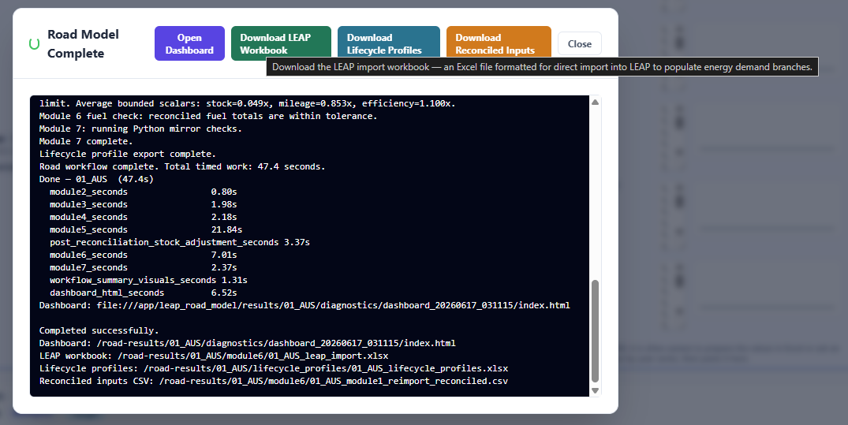
Original guide screenshot 1: road model download step.
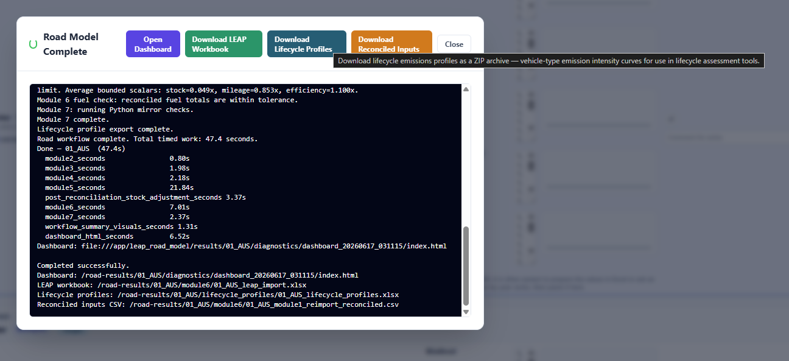
Original guide screenshot 2: road model download step.

5.3 Import the LEAP workbook
Open the generated LEAP workbook, then import it into the correct LEAP area. Use the standard APERC import-workbook process described in the LEAP workflow guide.
- Open the correct economy LEAP area.
- Make sure you are working in the intended economy area and scenario set.
- Open the generated road LEAP workbook in Excel.
- In LEAP, use the Excel import workflow to import the road expressions as data rather than spreadsheet links. Make sure to press the option for ID-based matching.
- After import, calculate or open the Results/Balances view so that LEAP solves and exposes any import problems.
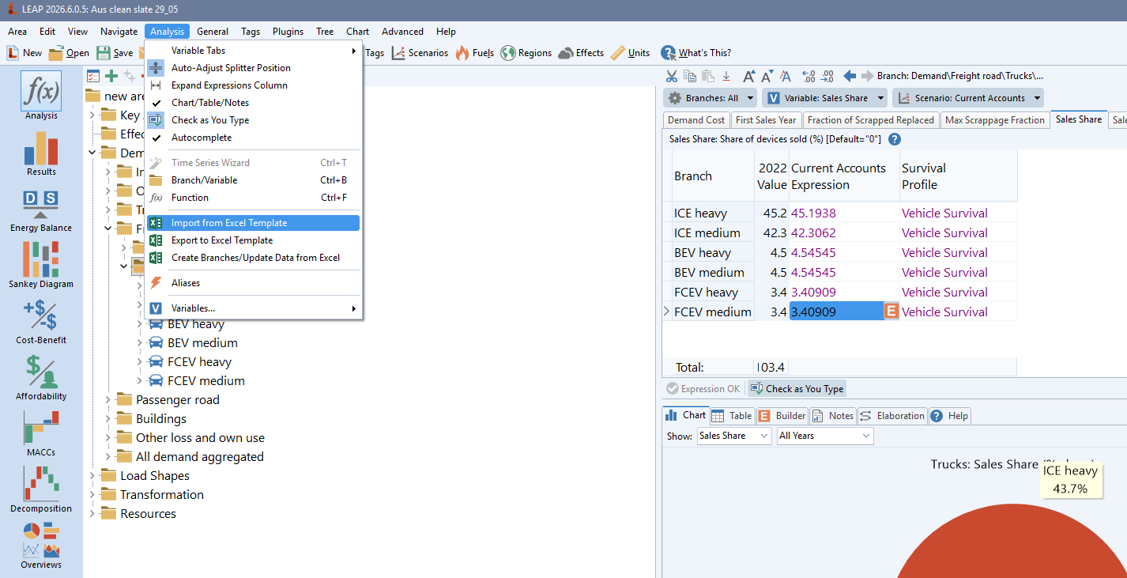
Original guide screenshot 3: workbook import step.
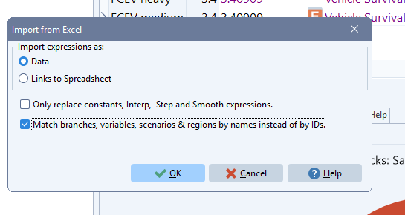
Original guide screenshot 4: workbook import step.
Important import point
The APERC model should generally import expressions as data rather than as live spreadsheet links. Live links can make a large LEAP area slower and harder to move or reproduce.

6. Setting lifecycle profiles in LEAP
The road-model web app prepares the lifecycle workbook for LEAP. It creates one named Excel range for each profile sheet, using the same name as the sheet. You do not need to select cells or define ranges in Excel.
The workbook contains two profile types:
- Survival curve: the probability that a vehicle is still on the road at each age.
- Vintage profile: the distribution of vehicle ages in the base-year fleet.
Keep the downloaded workbook open in Excel while you create and import the profiles in LEAP.

6.1 Create and import the profiles
1. Run the road model, select Download Lifecycle Profiles, and open the downloaded workbook in Excel.
2. Keep the workbook open. The web app has already created the named ranges, and every range has the same name as its profile sheet.
3. In LEAP, open Lifecycle Profiles and click Add Profile.
4. Enter the profile sheet name exactly as shown in Excel, for example Freight_vehicle_survival.
5. Click Import. In Excel Range, choose that same profile sheet name and select OK.
6. Repeat for the remaining profile sheets.
If a name is not listed, confirm that the newly downloaded workbook is open in Excel. Close other workbooks if needed, then try again.
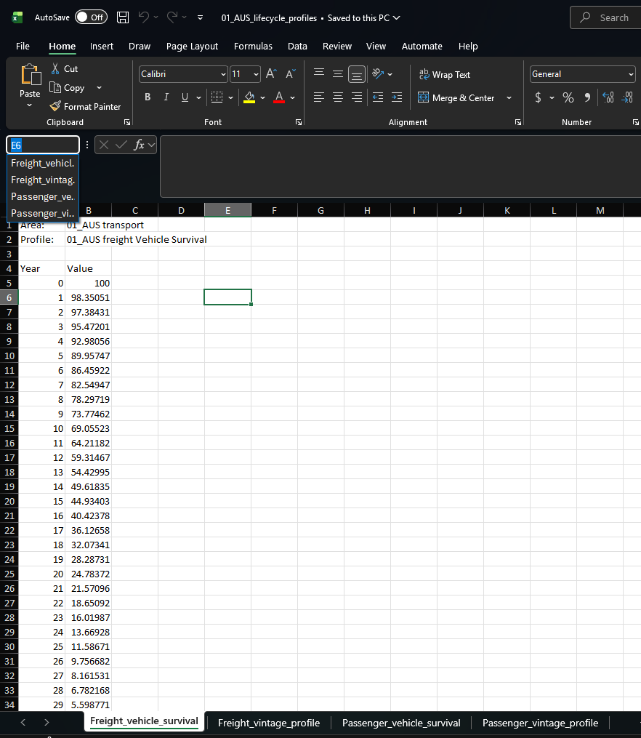
Step 1: Open the downloaded workbook and keep it open. The web app has already created a matching named range for each profile sheet.
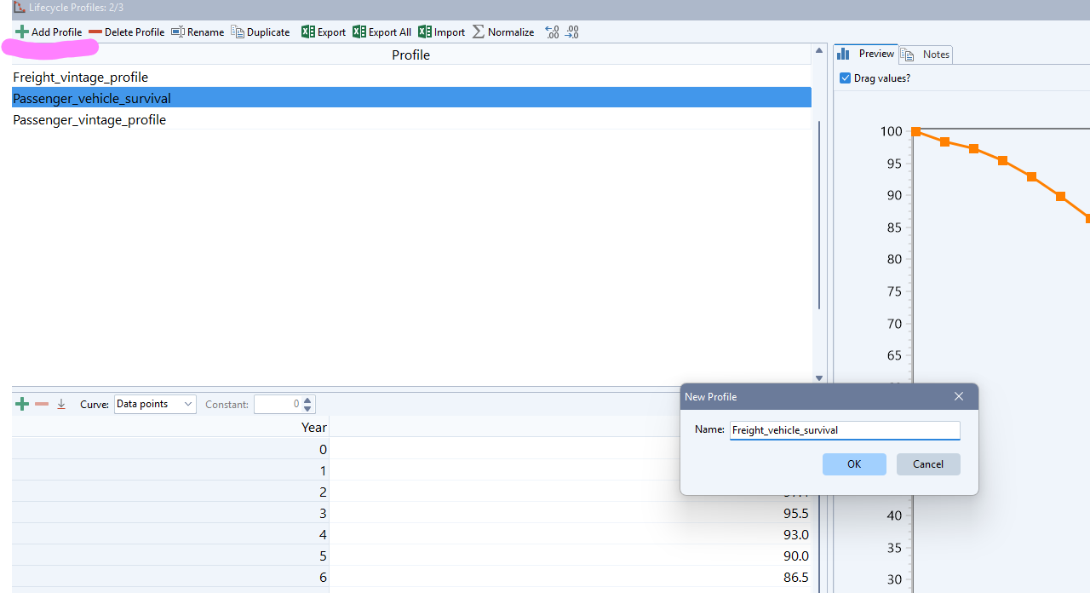
Step 2: In LEAP, click Add Profile and use the profile sheet name exactly as shown in Excel.
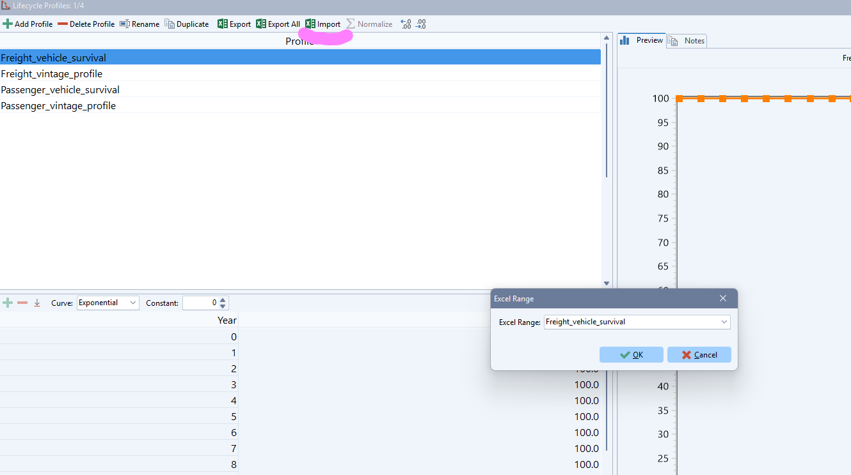
Step 3: Click Import and choose the named range with that same profile sheet name.

6.2 Assign lifecycle profiles in Current Accounts
Lifecycle profile settings are made in Current Accounts. They are not scenario-specific. This means there is no separate Reference or Target lifecycle profile unless the model structure is deliberately changed.
When setting them use ctrl-D to copy the setting from a cell above. This will make it so you don’t need to set everything in each branch for every fuel/technology.
Set the relevant lifecycle profiles for:
- Stock Vintage Profile;
- Sales and Sales Share settings where LEAP requires lifecycle profile links; and
- Mileage and fuel economy settings where profile-related variables are exposed.
- We haven’t built methods to create profiles for these variables but the ‘LEAP Transport exercise’ example area contains an example of what could be used. This is somewhere we could improve the transport model as it is.
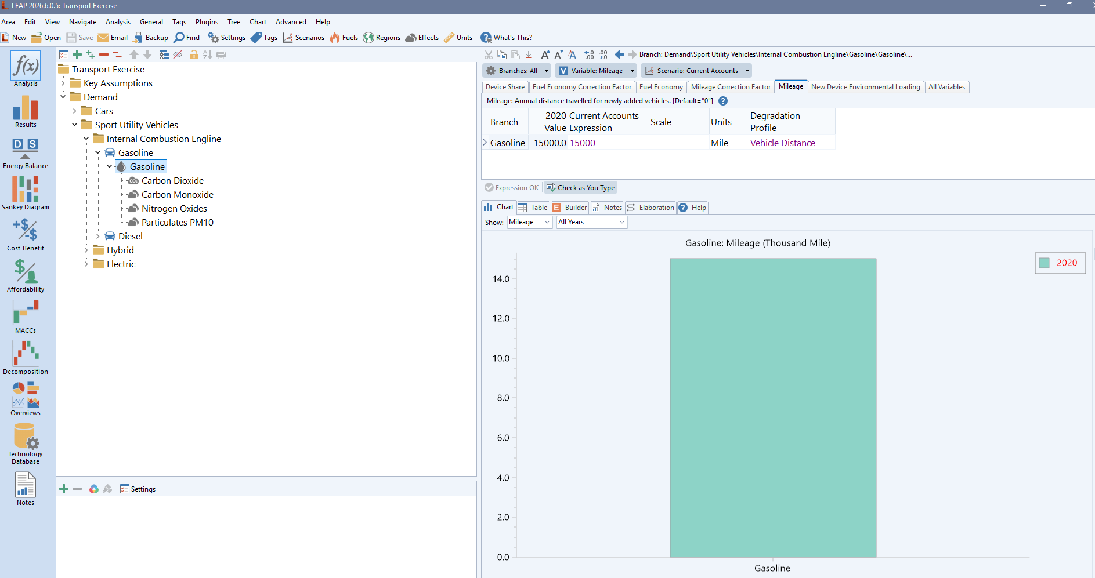
LEAP Transport exercise examples of the Vehicle distance profile for adjusting mileage as vehicles get older.
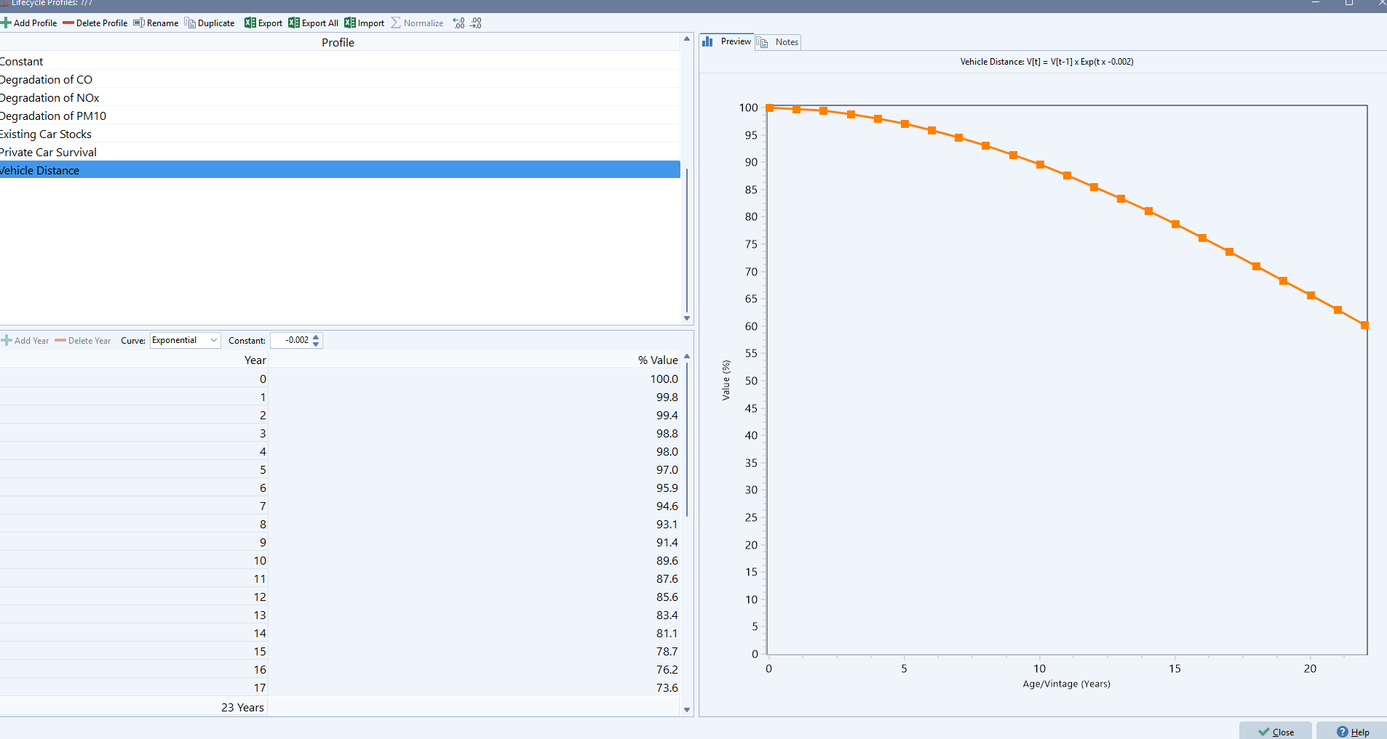
LEAP Transport exercise examples of the Vehicle distance profile for adjusting mileage as vehicles get older.
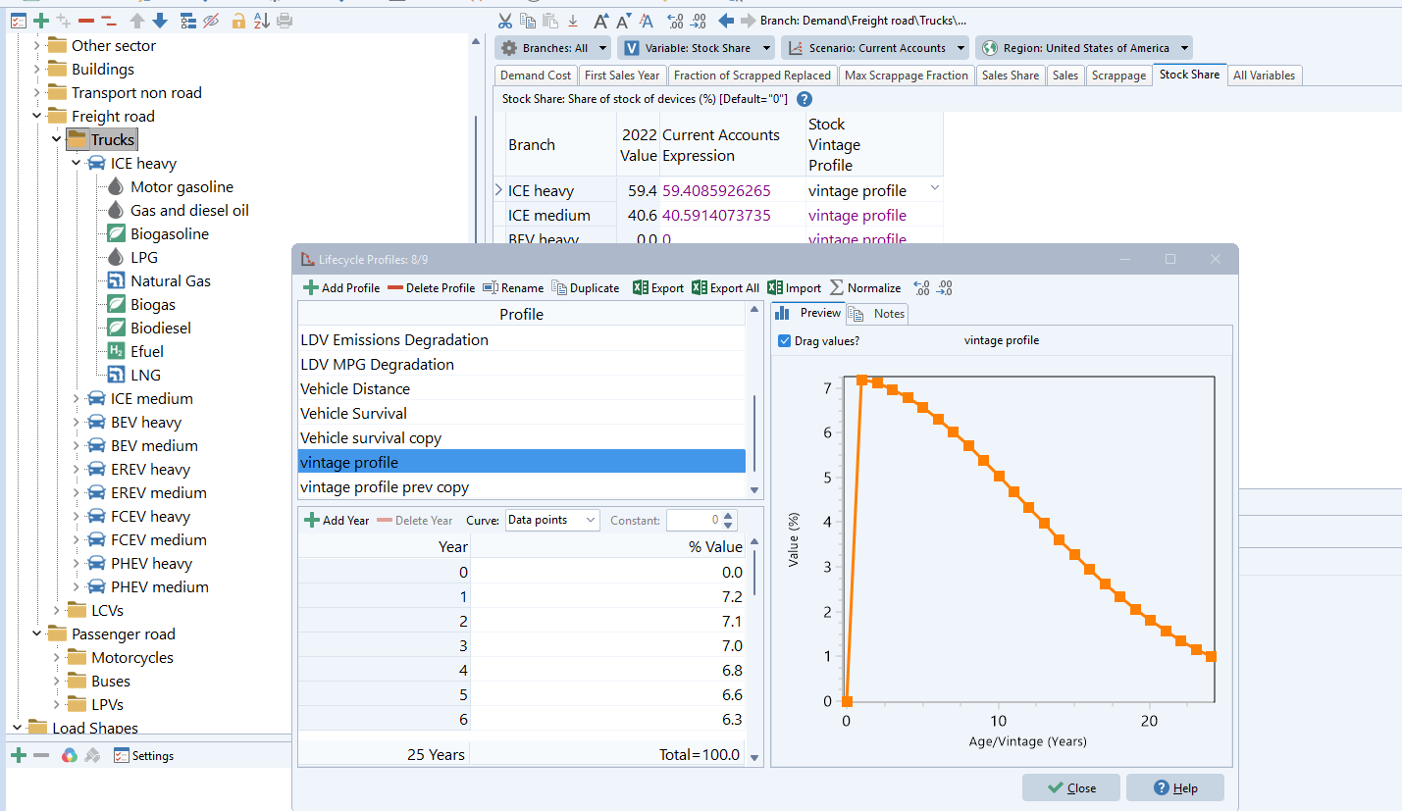
Original guide screenshot 8: lifecycle profile setting in LEAP.
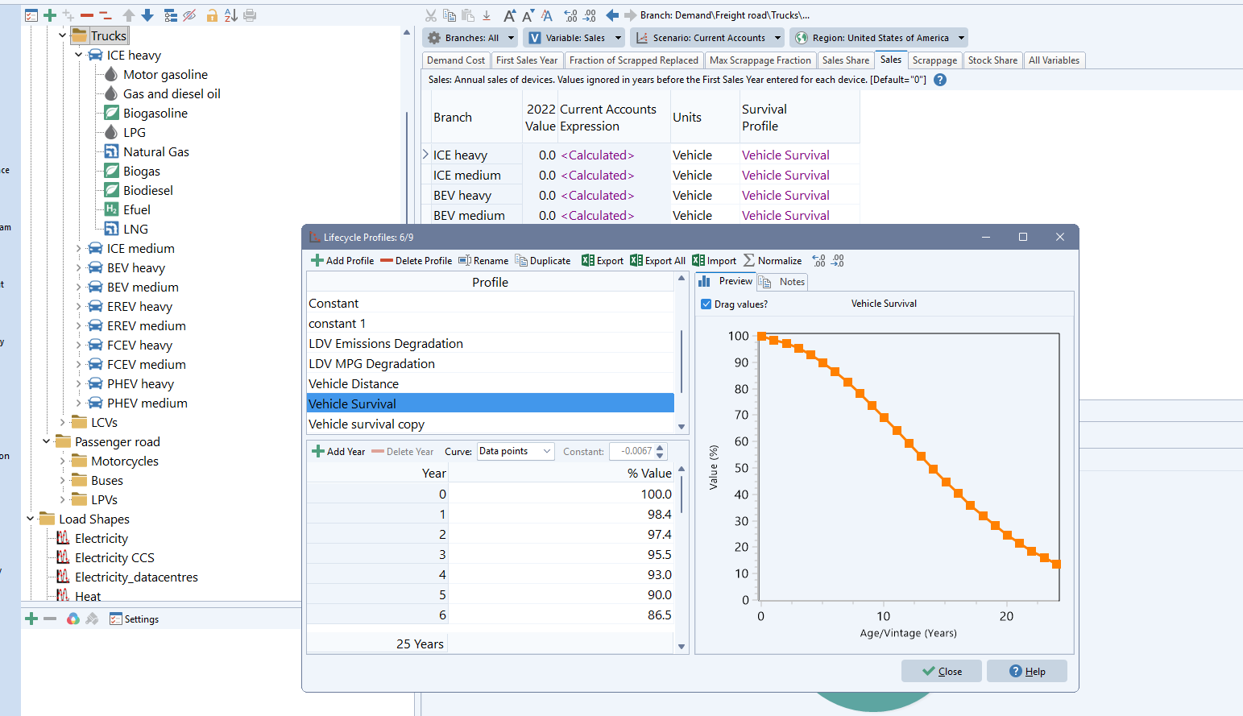
Original guide screenshot 9: lifecycle profile setting in LEAP.
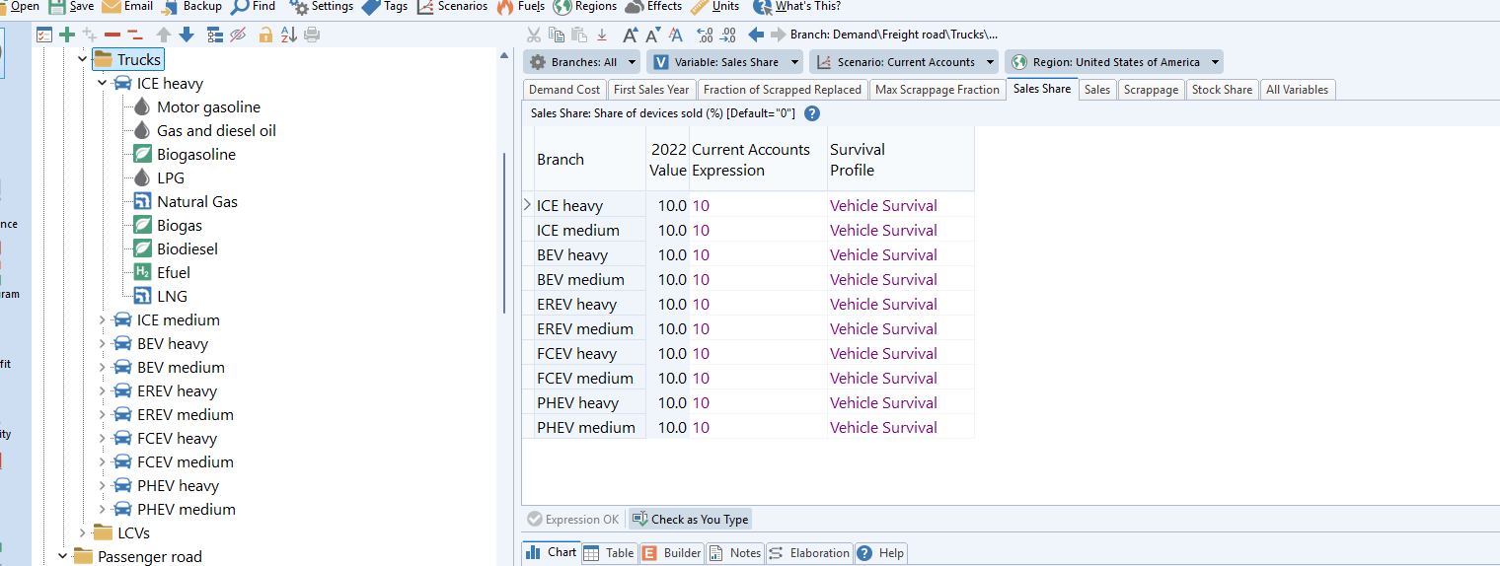
Original guide screenshot 10: lifecycle profile setting in LEAP.
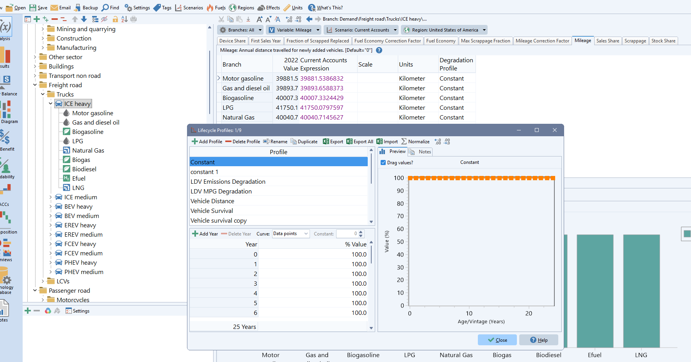
Original guide screenshot 11: lifecycle profile setting in LEAP.
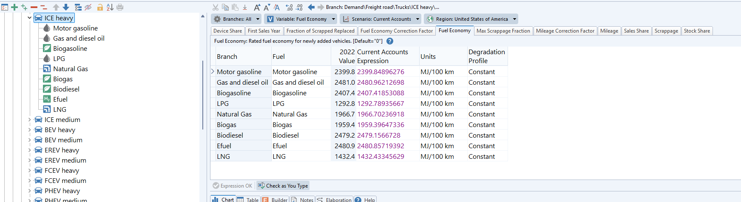
Original guide screenshot 12: lifecycle profile setting in LEAP.
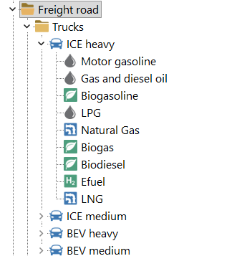
Original guide screenshot 13: lifecycle profile setting in LEAP.
Common source of confusion
LEAP sometimes exposes variables for lower-level branches through parent branch tabs. For example, engine-type settings may be visible while the vehicle-type branch is selected. Check the selected branch path and variable name before editing.

7. Road branch structure in LEAP
The road model branch hierarchy is:
Transport type > Vehicle type > Drive or engine type > Fuel type
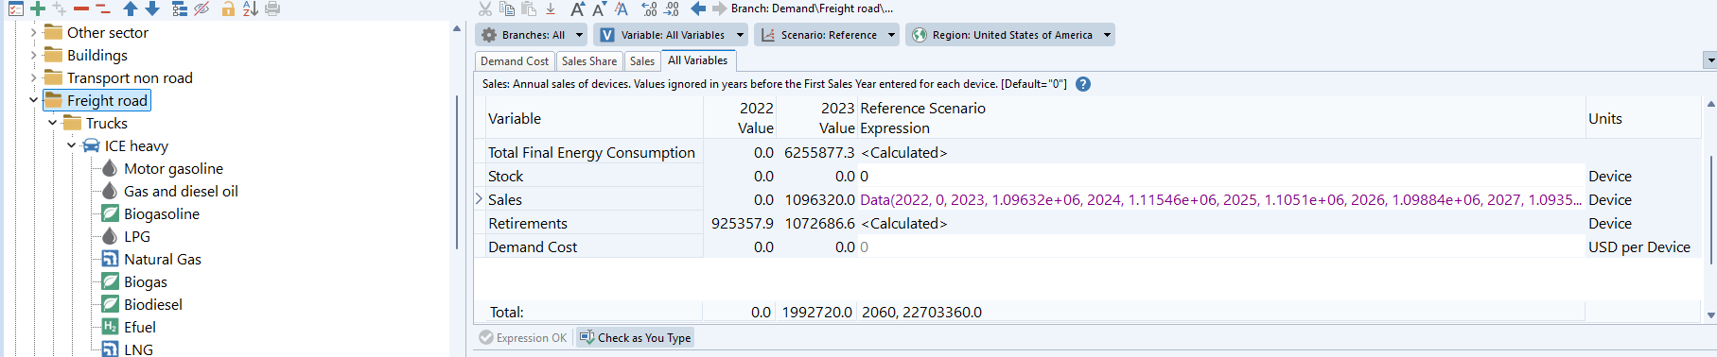
Original guide screenshot 14: road model branch structure.
The hierarchy matters because variables are defined at different levels. A change at a parent level can flow down to many child branches. A change at a fuel branch may affect only one fuel path.
Level | Examples | Main modelling role
Transport type | Passenger road; Freight road | Holds top-level stock, sales, and calculated total energy for the broad road segment.
Vehicle type | LPVs; Motorcycles; Buses; Trucks; LCVs | Splits the broad segment into vehicle categories. Current Accounts stock shares are important here.
Drive / engine type | ICE, HEV, PHEV, EREV, BEV, FCEV | Represents propulsion technology and controls technology sales shares and turnover. Sometimes also includes weight classes.
Fuel type | Motor gasoline, diesel, electricity, hydrogen, LPG, natural gas, biofuels, efuels | Represents the final fuel used by the branch and holds mileage, fuel economy, and Device Share variables.

8. What users can change in LEAP
The safest LEAP edits are scenario levers that change technology uptake, utilisation, or efficiency without rebuilding the stock-flow structure. These edits should normally be made in projection scenarios, not Current Accounts.
Change | Where to change it | What it does | Main checks
Technology uptake | Sales Share at vehicle-type or drive/engine level. | Changes which technologies enter the fleet through new sales. | Shares must sum to 100% within each parent; check stock changes gradually, not instantly.
Mileage Correction Factor | Mileage Correction Factor at fuel branches | Changes distance travelled per vehicle and therefore energy demand. Should not be changed without strong reasoning – these values often stay quite consistent across time. | Check energy changes directly; stock should not change just because mileage changed.
Efficiency Correction Factor | Fuel Economy Correction Factor at fuel branches | Changes energy use per kilometre. Average efficiency improvement of new vehicles (excluding engine type change) for the last 20 years has been 1.5-2%/yr avg and for the whole fleet, ~0.3–1.0%/yr improvement, because old vehicles remain in the fleet. | Check the unit direction before deciding whether the factor should rise or fall.
Fuel split within a technology | Device Share at fuel branches. | Changes how a technology branch is split across fuels. | Device Shares under one parent must sum to 100%; PHEV/EREV Device Shares should usually come from the pre-LEAP utilization workflow as it is hard to back-calculate the resulting electricity utilization shares.
Technology availability | First Sales Year. | Prevents a technology from receiving sales before a specified year. | Check whether sales shares before that year are ignored or reallocated as intended.
Scrappage / accelerated retirement | Scrappage-related variables at drive/engine type branches. | Can accelerate retirement beyond normal survival profiles. | Advanced only. Check sales, retirements, stock, and replacement assumptions together.

Scenario editing principle
Make one major change at a time, calculate LEAP, then check stock, sales, energy by fuel, and balance outputs before making the next change. This makes it much easier to explain why results changed. Try using the notes feature to keep track of changes.

9. Variables by branch level
This section summarises the variables users are most likely to see in LEAP. Some variables appear in different tabs depending on the selected branch. Always check the branch path, scenario, variable, and units before editing.

9.1 Transport type branches
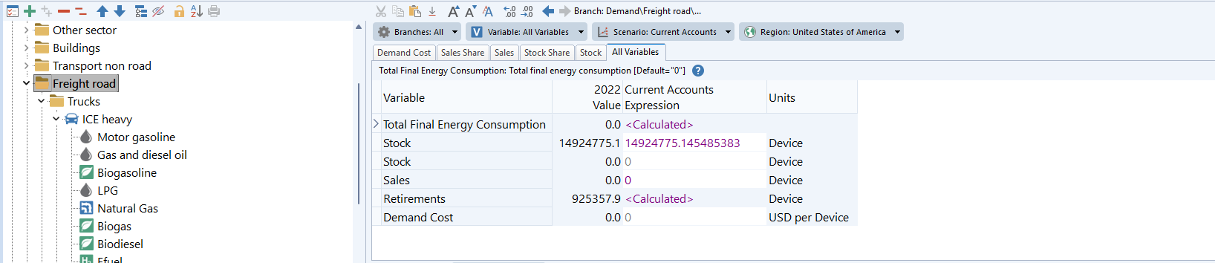
Original guide screenshot 15: transport-type variables.
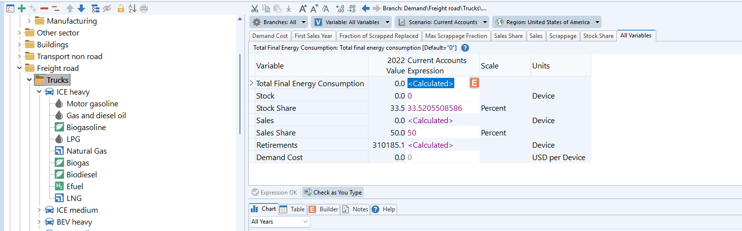
Original guide screenshot 16: transport-type variables.
Variable | Meaning | Can user edit?
Total Final Energy Consumption | Calculated total energy use for the transport type. | No. This is a result.
Stock | Total number of vehicles in the transport type. | Usually imported. Do not manually change projection stock unless deliberately rebuilding the workflow.
Sales | Total new sales entering the transport type. | Usually imported from the road workflow. Do not use as a casual scenario lever.
Retirements | Vehicles leaving the stock. | No. Calculated from stock-flow/lifecycle assumptions.

9.2 Vehicle type branches
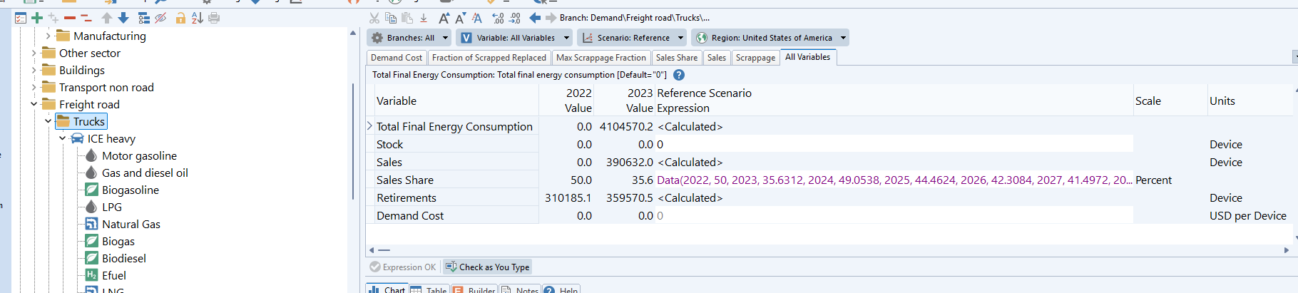
Original guide screenshot 17: vehicle-type variables.
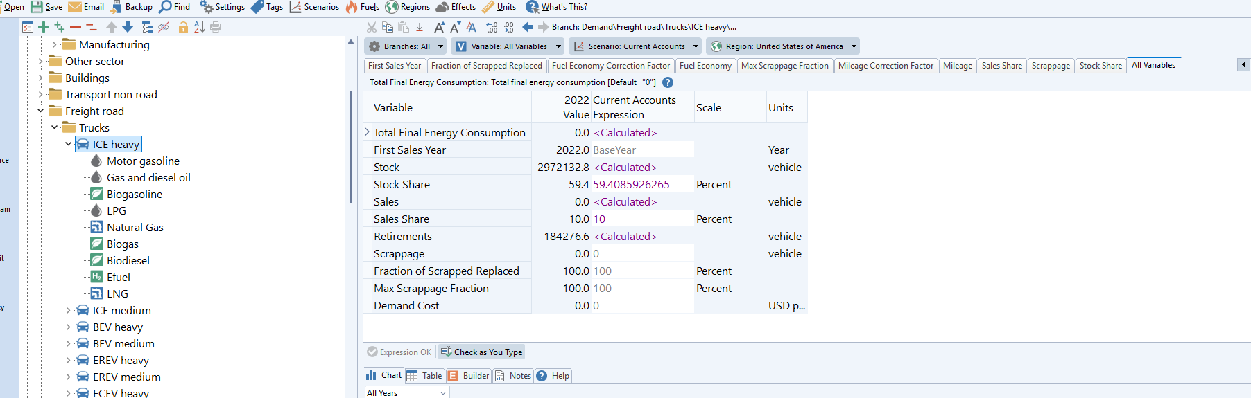
Original guide screenshot 18: vehicle-type variables.
Variable | Meaning | Can user edit?
Total Final Energy Consumption | Calculated energy use for the vehicle type. | No. This is a result.
Stock | Vehicle-type stock. | Current Accounts imported. Projection values should come from the road workflow.
Stock Share | Share of parent stock allocated to this vehicle type. | Current Accounts imported. Projection changes should usually be made before LEAP, especially for LPV/motorcycle/bus shares.
Sales | New sales for the vehicle type. | Calculated or imported. Avoid manual edits unless part of a deliberate workflow.
Sales Share | Share of parent sales allocated to this vehicle type. | Possible scenario lever only where reviewed. For passenger vehicle-type shifts, prefer pre-LEAP workflow.
Retirements | Vehicles of this type leaving the stock. | No. Calculated.

9.3 Drive / engine type branches
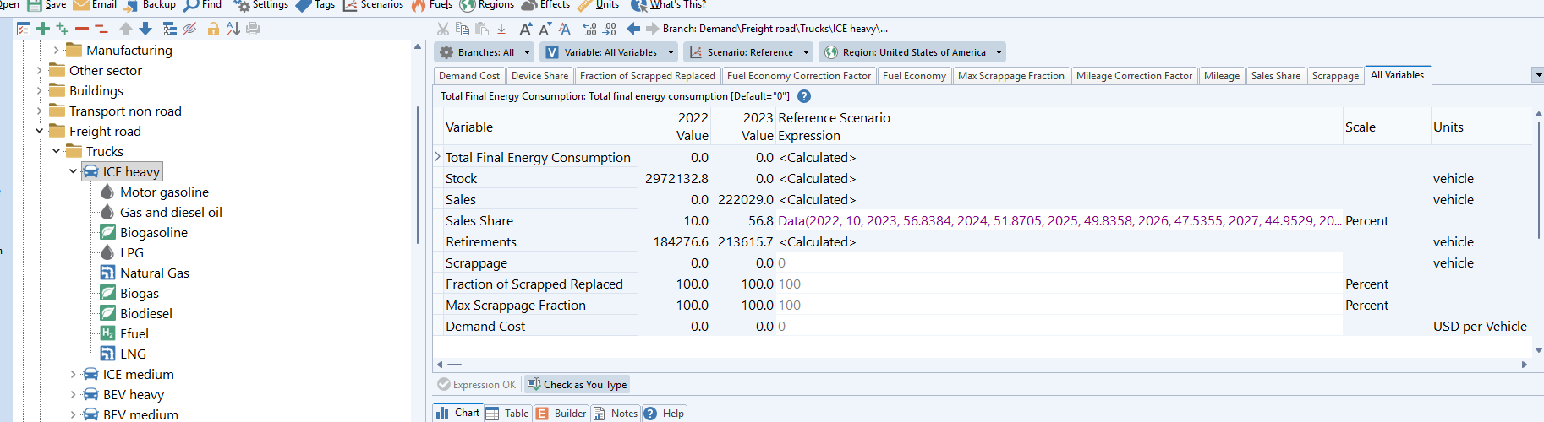
Original guide screenshot 19: drive or engine-type variables.
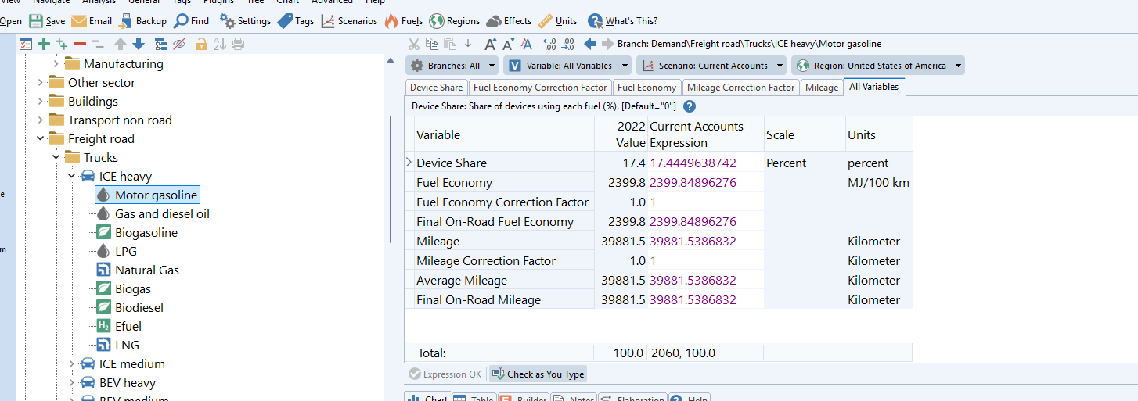
Original guide screenshot 20: drive or engine-type variables.
Variable | Meaning | Can user edit?
Total Final Energy Consumption | Energy use for the technology across all fuels. | No. Calculated.
First Sales Year | First year in which LEAP allows sales for that branch. | Yes, but only if the technology is not available before a chosen year and the effect is checked.
Stock | Technology stock. | No routine manual edits. It is an outcome of sales, retirements, and imported stock-flow assumptions.
Stock Share | Technology share of parent stock. | Current Accounts imported. Avoid projection edits unless you understand the turnover implications.
Sales | Technology sales. | Calculated from parent sales and Sales Share.
Sales Share | Share of parent sales going to this technology. | Yes. This is one of the main LEAP scenario levers. Shares must sum to 100% within the parent.
Scrappage | Additional early retirement beyond normal survival. | Experimental / advanced. Use only with careful checks.
Fraction of Scrapped Replaced | Share of scrapped vehicles replaced by new sales. | Advanced. Affects sales and stock-flow behaviour.
Max Scrappage Fraction | Limit on how much stock can be scrapped in a year. | Advanced. Use only in a tested scrappage workflow.

9.4 Fuel branches
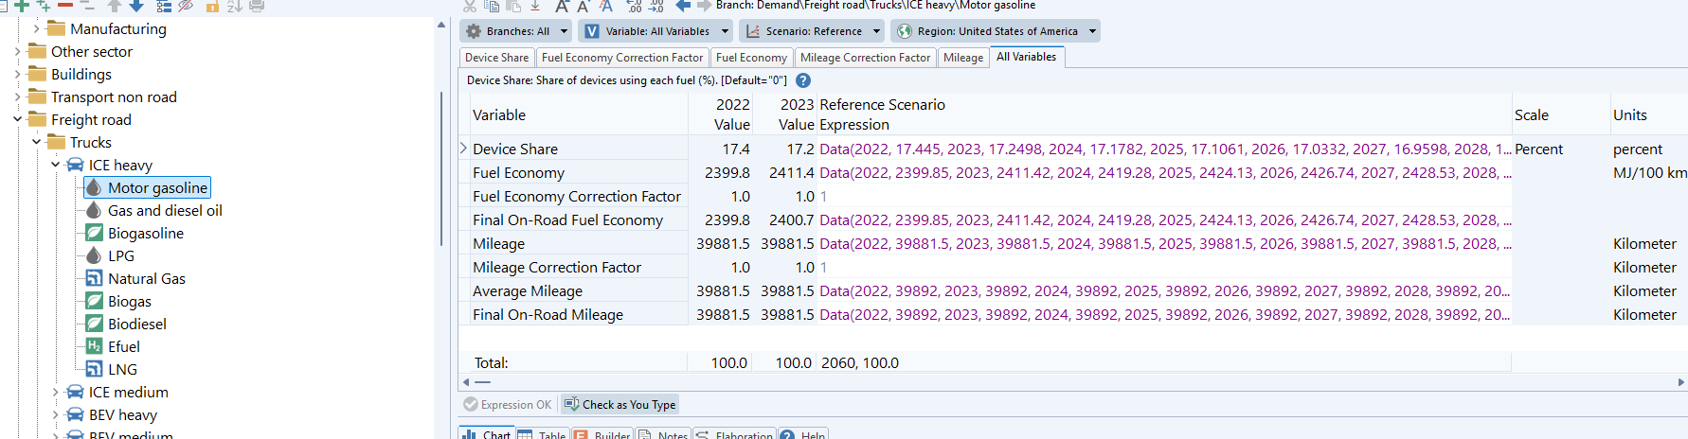
Original guide screenshot 21: fuel-branch variables.
Variable | Meaning | Can user edit?
Device Share | Share of the parent technology branch allocated to this fuel. | Usually imported after reconciliation. Edit only if deliberately changing fuel split and check shares sum to 100%.
Fuel Economy | Base fuel economy or efficiency value, depending on LEAP units. | Usually imported. Scenario changes should normally use correction factors if available.
Fuel Economy Correction Factor | Multiplier applied to fuel economy. | Yes. Useful for efficiency improvement scenarios. Check unit direction.
Final On-Road Fuel Economy | Effective fuel economy after correction factors. | No. Result of base value and correction factor.
Mileage | Annual distance travelled per vehicle. | Usually imported. Scenario changes should normally use correction factors if available.
Mileage Correction Factor | Multiplier applied to mileage. | Yes. Useful for travel-demand or utilisation scenarios.
Average Mileage | Mileage after profile effects. | No. Calculated.
Final On-Road Mileage | Effective mileage used in the final calculation. | No. Result of base value and correction factor.

10. Walkthroughs for common modelling changes

10.1 Increase BEV uptake for LPVs
1. Select the projection scenario you want to edit, usually Target or a test scenario.
2. Go to the relevant LPV branch under Demand > Passenger road > LPVs.
3. Find the Sales Share variables for the drive or engine types under that parent, such as ICE, HEV, PHEV, BEV, and FCEV, and for size branches where relevant.
4. Increase the BEV Sales Share pathway for the years you want to change.
5. Reduce one or more other technology Sales Shares so the shares under the same parent still sum to 100%.
6. Calculate LEAP and check that BEV sales rise first, then BEV stock rises gradually through turnover.
7. Check electricity demand, liquid fuel demand, and total final energy consumption.
Expected behaviour
A large BEV sales share does not instantly make the whole fleet BEV. It affects new sales first, then stock gradually as older vehicles retire.

10.2 Reduce vehicle use through lower mileage
1. Choose the scenario and branch you want to affect, such as Passenger road LPV gasoline ICE branches or Freight road truck diesel branches.
2. At the relevant fuel branches, find Mileage Correction Factor or the reviewed mileage variable.
3. Enter the pathway for reduced utilisation. For example, a factor below 1 reduces mileage if the correction factor is multiplicative.
4. Calculate LEAP.
5. Check that energy demand falls for the affected branches while vehicle stock and sales remain broadly unchanged.
Interpretation
Mileage changes are useful for behavioural, utilisation, modal-shift, or activity-demand assumptions. They do not by themselves change how many vehicles are in the fleet.

10.3 Improve fuel economy or efficiency
1. Choose the scenario and relevant fuel branches.
2. Find Fuel Economy Correction Factor or another reviewed efficiency variable.
3. Check whether the displayed unit is energy per distance or distance per energy.
4. Apply the pathway. If the variable is distance per energy, a higher value usually reduces energy use. If it is energy per distance, a lower value usually reduces energy use.
5. Calculate LEAP and check that energy demand changes in the expected direction.
6. Compare the effect by technology because BEVs, ICE vehicles, and FCEVs may have very different starting efficiencies.

10.4 Change PHEV or EREV electric driving share
PHEV and EREV branches use both electricity and gasoline-family liquid fuels. Their electric/liquid split is normally prepared before LEAP using a PHEV utilisation assumption.
1. Do not start by manually editing PHEV or EREV Device Shares in LEAP.
2. Change the PHEV utilisation assumption in the interface or Module 1 package.
3. Rerun the road workflow so electricity and liquid fuel are recalculated consistently.
4. Either
a. Import the updated LEAP workbook if you are happy with overwriting everything in the road model in LEAP.
b. Delete all non-device share rows and all rows for branches except the ones you want to change, then import.
5. Check PHEV utilisation diagnostics through the leap road model dashboard and confirm that electricity and liquid fuel demands are plausible within the LEAP results

10.5 Test an accelerated ICE scrappage policy
Scrappage is an advanced scenario lever because it affects retirements, replacement sales, technology uptake, stock, and energy at the same time. It should be tested cautiously.
1. Save progress and make a note in the Notes section of what you will be doing.
2. Choose the ICE branches affected by the policy.
3. Apply Scrappage, Fraction of Scrapped Replaced, and Max Scrappage Fraction assumptions as you need.
4. Check whether scrapped vehicles are replaced as intended.
5. Check sales, retirements, stock, BEV/PHEV/FCEV uptake, and fuel demand together.
6. Document the policy assumption and the reason for the chosen values.

10.6 Shift from LPVs to buses or motorcycles
This should normally be done before LEAP, not by directly editing vehicle-type shares inside LEAP.
Reason: passenger vehicle-type shares are connected to vehicle-equivalent ownership. A bus represents much more passenger capacity than one LPV, while a motorcycle represents a smaller unit. Changing the LPV/bus/motorcycle mix therefore changes the physical stock and sales pathway, not just the branch split.
1. Change the passenger vehicle-type share assumptions in the interface or road workflow.
2. Rerun the stock target and turnover workflow.
3. Review stock and sales paths for LPVs, motorcycles, and buses.
4. Either
a. Import the updated LEAP workbook if you are happy with overwriting everything in the road model in LEAP.
b. Delete all stock and stock share rows and all rows for branches except the ones you want to change, then import.
5. Check that total passenger energy and vehicle-type energy change in a way that is consistent with the intended transport story.

10.7 Why is LNG not included in the default truck sales-share settings?
LNG is not shown in the default truck Sales Share settings because the road model treats LNG trucks as ICE trucks, not as a separate drive technology. In the road branch structure, Sales Share controls how new trucks are split between drive types such as ICE, BEV, and FCEV. LNG is handled one level lower, as a fuel used within the ICE truck branch.
To represent LNG trucks, adjust the Device Share at the fuel branches under the relevant ICE truck branch. Device Share represents the fuel split within that drive type. For example, it can be used to represent diesel versus LNG use in ICE trucks, biofuel blending within ICE vehicles, or the electricity/liquid split for PHEVs and EREVs.
Example:
Demand
Freight road
Trucks
ICE heavy
Gas and diesel oil Device Share = 90%
LNG Device Share = 10%
This means that all of these vehicles are still counted as ICE heavy trucks, but 10% of the ICE heavy truck fuel/device split is assigned to LNG rather than diesel. The ICE truck sales share itself does not need to include a separate LNG category.
When making this change, check that all Device Share values under the same ICE truck branch sum to 100%. Also check the resulting fuel demand by fuel after solving LEAP. If LNG trucks are expected to have a materially different efficiency from diesel trucks, the relevant Fuel Economy Correction Factor may also need to be reviewed, but the first step is normally to represent the fuel switch through Device Share.

11. What users should not change directly in LEAP
The following items should generally not be changed directly in LEAP unless a modeller is deliberately rebuilding or testing the road model structure.
Do not directly change | Why not | Use this instead
Branch structure | The import workbook depends on matching LEAP branch IDs and paths. Renaming or moving branches can break imports. | Change the branch configuration and regenerate the LEAP reference export.
Scenario and region names | The import workbook and result workflows depend on these names and IDs. | Use standard APERC scenario and economy setup.
Current Accounts base-year stock, mileage, or fuel economy after import | These values have been reconciled to ESTO. Manual edits can break the base-year balance. | Change through the pre-LEAP road workflow.
Passenger vehicle-type stock shares in projection years | They affect vehicle-equivalent ownership, stock targets, sales, and retirements. | Change through the pre-LEAP road workflow.
Survival and vintage profiles | They change retirements and sales across the full fleet and are calculated based on the stock trajectory. | Change through the pre-LEAP road workflow.
PHEV/EREV Device Shares casually | They encode the electric/liquid utilisation split and reconciliation outcome. | Change through the pre-LEAP road workflow.

12. Checking the model after changes
After importing the road workbook or making LEAP scenario edits, calculate the model and check results in this order.
1. Check that LEAP calculates without import or expression errors.
2. Check passenger road and freight road total final energy consumption.
3. Check fuel totals: gasoline, diesel, electricity, hydrogen, LPG, natural gas, biofuels, and any efuels if present.
4. Check stock and sales by vehicle type and drive type.
5. Check that a technology sales-share change affects stock gradually through turnover.
6. Check that Device Shares sum to 100% within each parent technology branch.
7. Check that PHEV/EREV electricity and liquid demand are plausible.
8. Check the Energy Balance view to confirm that road demand is being integrated correctly with transformation and supply.
9. Export results and compare against dashboard or Python mirror outputs where available.
If you see... | Likely cause | First thing to check
Huge jump in a fuel demand | Sales share, Device Share, mileage, or fuel economy path may have been entered at the wrong level or with wrong units. | Branch path, units, and whether the expression was applied to too many child branches.
BEV stock does not rise despite BEV Sales Share increasing | First Sales Year, sales-share sum, parent sales, or lifecycle turnover may be constraining uptake. | BEV Sales Share, First Sales Year, total sales, and retirements.
Fleet changes instantly rather than gradually | Stock Share may have been edited instead of Sales Share. | Whether the edit was made to Stock Share or Sales Share.
Base-year fuel totals no longer match ESTO | Manual edits may have changed imported Current Accounts values. | Current Accounts stock, mileage, fuel economy, and Device Shares.
PHEV electricity/liquid split looks wrong | Device Shares may have been edited manually or utilisation assumption may be unsuitable. | PHEV utilisation assumption and Device Shares.
LEAP import fails or rows are skipped | Branch, variable, scenario, region, or IDs do not match the LEAP area. | Use the reference export and confirm branch structure has not changed.

13. Common problems and how to diagnose them

13.1 Workbook imports but results do not change
- Check that the import was applied to the correct scenario and region.
- Check whether expressions were imported as data, not as links to an unexpected workbook.
- Check whether the variable you imported is actually used by the selected LEAP branch.
- Check whether a parent expression is overriding child branches.

13.2 Sales shares do not sum to 100%
Sales shares should sum to 100% within the relevant parent branch for every year. If one technology share is increased, another share usually needs to fall. Use a remainder expression only where that is part of the reviewed workflow.

13.3 Fuel economy change moves energy in the wrong direction
This usually means the unit convention has been misunderstood. If the value is distance per unit energy, increasing it means vehicles travel further for the same energy and total energy falls. If the value is energy per distance, increasing it means vehicles use more energy per kilometre and total energy rises.

13.4 LEAP shows variables from lower branches at a parent branch
This is a LEAP interface issue that can be confusing. Check the selected branch, the variable tab, and the branch path shown in the expression row. Do not assume that a visible variable belongs only to the selected parent branch.

13.5 Road demand creates unexpected wider energy-balance effects
Road fuel demand is part of the wider LEAP energy system. Changes to road electricity demand can affect power generation. Changes to liquid fuel demand can affect refining, oil products, imports, exports, and Resources. If a road change creates unexpected imports, exports, or unmet requirements, first confirm that road fuel demand is sensible, then check transformation and supply settings.
13.6 Stocks/Retirements/Sales are not as expected
If you see anything that doesn’t match the trends from the Leap-simulation in the Road model interface, chances are that you may have recorded the wrong lifecycle profile in the Current Accounts scenario. For example, retirements should be positive but if you record the wrong survival profile, it may be that they are negative which is wrong.

14. Glossary
Term | Meaning
Current Accounts | The base-year calibration scenario. Existing stock, starting shares, mileage settings, and lifecycle profiles are normally set here.
Projection scenario | A future scenario such as Reference or Target. Scenario assumptions for sales shares, efficiency, mileage, and other variables are applied here.
Stock | Number of vehicles in operation.
Sales | New vehicles added in a year.
Retirements | Vehicles leaving the fleet, usually through survival-profile turnover or scrappage.
Survival curve | Probability a vehicle is still on the road at each age.
Vintage profile | Age distribution of the base-year fleet.
Lifecycle profile | LEAP profile used to represent survival or vintage behaviour.
Sales Share | Share of a parent branch’s sales allocated to a child branch. Main technology uptake lever.
Stock Share | Share of a parent branch’s stock allocated to a child branch. Mostly used for Current Accounts or structural setup.
Device Share | Fuel split within a technology branch. Shares under a parent should sum to 100%.
Mileage | Average distance travelled per vehicle per year.
Fuel Economy / Efficiency | Relationship between travel and energy use. Interpret carefully because units may be energy per distance or distance per energy.
Scrappage | Additional early retirement beyond normal survival behaviour.
PHEV utilisation | Share of PHEV/EREV travel assumed to be electric. Used to prepare electricity/liquid fuel splits.
Reconciliation | Adjustment process that aligns bottom-up road energy with ESTO base-year fuel totals.
ESTO | The official APERC energy balance data source used for historical energy totals.
Python mirror | Optional QA calculation that approximates LEAP-like stock and energy outputs. It is not the official projection.

Appendix A. Current road branch scope
The current road branch scope is designed to provide detail where it is useful without making every branch equally complex. LPVs receive the most detail because they are usually the largest and most policy-relevant part of the fleet.
Passenger road:
- LPVs: ICE, HEV, EREV, PHEV, BEV, FCEV; with small, medium, and large size labels where relevant.
- Motorcycles: ICE, BEV, FCEV.
- Buses: ICE, BEV, FCEV.
Freight road:
- Trucks: ICE, BEV, FCEV; with medium and heavy size labels where relevant.
- LCVs: ICE, PHEV, BEV, FCEV.
Main scope rules:
- HEV and EREV are LPV-only in the current road model.
- Truck PHEV is out of scope in the current model.
- PHEV and EREV liquid fuel is treated as gasoline-family fuel in the current reconciliation workflow.
- Electricity is used by BEV, PHEV, and EREV branches.
- Hydrogen is used by FCEV branches.
- Biofuels follow the same broad branch family as their fossil counterparts, but should not be interpreted as a separate dedicated vehicle fleet unless the model is explicitly changed.

Appendix B. Screenshot reference from the original guide
The screenshots below were retained from the original draft guide as visual references. They may need updated captions or replacement screenshots once the final interface and LEAP screens are stable.
Original screenshot group | Used in this guide
Download buttons | Section 5.2
LEAP workbook import | Section 5.3
Lifecycle profile named ranges and import | Section 6.1
Lifecycle profile assignment in LEAP | Section 6.2
Branch structure and variables by level | Sections 7 and 8

Source material used
This revised guide consolidates and rewrites material from the following project documents:
- leap transport guide.docx
- road_transport_model_overview.md
- road_transport_model_methodology.md
- road_transport_model_modeller_guide.md
- transport model documentation.docx
- Understanding the LEAP Modelling Approach.docx
- Leap workflow guide.docx, for the general import-workbook workflow.
It is intended to replace the draft practical guide, not the technical methodology or developer workflow documentation.

